**Headquarters**

version 12.2

no service timestamps log datetime msec

no service timestamps debug datetime msec

no service password-encryption

!

hostname headquarters

!

!

!

!

!

!

!

!

no ip cef

no ipv6 cef

!

!

!

username leader privilege 15 password 0 leader1

!

!

!

!

!

!

!

!

ip ssh version 2

ip domain-name headquarters

!

!

!

!

!

!

!

!

interface Serial0/0

ip address 192.168.28.77 255.255.255.252

clock rate 2000000

!

interface Serial1/0

ip address 192.168.28.65 255.255.255.252

!

interface Serial2/0

ip address 192.168.28.69 255.255.255.252

clock rate 2000000

!

interface Serial3/0

ip address 192.168.28.73 255.255.255.252

!

interface FastEthernet8/0

ip address 192.168.16.1 255.255.248.0

duplex auto

speed auto

!

interface Ethernet9/0

no ip address

duplex auto

speed auto

shutdown

!

router rip

version 2

network 192.168.16.0

network 192.168.28.0

!

ip classless

ip route 192.168.28.32 255.255.255.224 Serial0/0

ip route 192.168.0.0 255.255.240.0 Serial1/0

ip route 192.168.28.0 255.255.252.0 Serial3/0

ip route 192.168.24.0 255.255.252.0 Serial2/0

!

ip flow-export version 9

!

!

!

!

!

!

!

!

line con 0

!

line aux 0

!

line vty 0 4

login local

transport input ssh

line vty 5 15

login local

transport input ssh

!

!

!

end

**Intelligence**

!

version 12.2

no service timestamps log datetime msec

no service timestamps debug datetime msec

no service password-encryption

!

hostname Router

!

!

!

!

!

!

!

!

no ip cef

no ipv6 cef

!

!

!

!

!

!

!

!

!

!

!

!

!

!

!

!

!

!

interface Serial0/0

ip address 192.168.28.82 255.255.255.252

clock rate 2000000

!

interface Serial1/0

ip address 192.168.28.97 255.255.255.252

!

interface Serial2/0

ip address 192.168.28.70 255.255.255.252

!

interface Serial3/0

ip address 192.168.28.93 255.255.255.252

!

interface FastEthernet8/0

ip address 192.168.24.1 255.255.252.0

ip helper-address 192.168.16.16

duplex auto

speed auto

!

router rip

version 2

network 192.168.24.0

network 192.168.28.0

!

ip classless

ip route 192.168.0.0 255.255.240.0 Serial0/0 10

ip route 192.168.16.0 255.255.248.0 Serial2/0

ip route 192.168.28.32 255.255.255.224 Serial1/0 10

ip route 192.168.28.0 255.255.255.224 Serial3/0 10

!

ip flow-export version 9

!

!

!

!

!

!

!

!

line con 0

!

line aux 0

!

line vty 0 4

login

!

!

!

end

**Lobby**

version 12.2

no service timestamps log datetime msec

no service timestamps debug datetime msec

no service password-encryption

!

hostname Router

!

!

!

!

!

!

!

!

no ip cef

no ipv6 cef

!

!

!

!

!

!

!

!

!

!

!

!

!

!

!

!

!

!

interface Serial0/0

ip address 192.168.28.81 255.255.255.252

!

interface Serial1/0

ip address 192.168.28.66 255.255.255.252

clock rate 2000000

!

interface Serial2/0

ip address 192.168.28.85 255.255.255.252

clock rate 2000000

!

interface Serial3/0

ip address 192.168.28.89 255.255.255.252

clock rate 2000000

!

interface FastEthernet8/0

ip address 192.168.0.1 255.255.240.0

ip helper-address 192.168.16.16

duplex auto

speed auto

!

router rip

version 2

network 192.168.0.0

network 192.168.28.0

!

ip classless

ip route 192.168.16.0 255.255.248.0 Serial1/0

ip route 192.168.24.0 255.255.252.0 Serial1/0

ip route 192.168.28.0 255.255.255.224 Serial1/0

ip route 192.168.28.32 255.255.255.224 Serial1/0

!

ip flow-export version 9

!

!

!

!

!

!

!

!

line con 0

!

line aux 0

!

line vty 0 4

login

!

!

!

End

**Mercenary**

!

version 12.2

no service timestamps log datetime msec

no service timestamps debug datetime msec

no service password-encryption

!

hostname Router

!

!

!

!

!

!

!

!

no ip cef

no ipv6 cef

!

!

!

!

!

!

!

!

!

!

!

!

!

!

!

!

!

!

interface Serial0/0

ip address 192.168.28.101 255.255.255.252

clock rate 2000000

!

interface Serial1/0

ip address 192.168.28.86 255.255.255.252

!

interface Serial2/0

ip address 192.168.28.94 255.255.255.252

clock rate 2000000

!

interface Serial3/0

ip address 192.168.28.74 255.255.255.252

clock rate 2000000

!

interface FastEthernet8/0

ip address 192.168.28.1 255.255.255.224

ip helper-address 192.168.16.16

duplex auto

speed auto

!

router rip

version 2

network 192.168.28.0

!

ip classless

ip route 192.168.0.0 255.255.240.0 Serial3/0

ip route 192.168.16.0 255.255.248.0 Serial3/0

ip route 192.168.24.0 255.255.252.0 Serial3/0

ip route 192.168.28.32 255.255.255.224 Serial3/0

!

ip flow-export version 9

!

!

!

!

!

!

!

!

line con 0

!

line aux 0

!

line vty 0 4

login

!

!

!

end

**undertaking**

!

version 12.2

no service timestamps log datetime msec

no service timestamps debug datetime msec

no service password-encryption

!

hostname Router

!

!

!

!

!

!

!

!

no ip cef

no ipv6 cef

!

!

!

!

!

!

!

!

!

!

!

!

!

!

!

!

!

!

interface Serial0/0

ip address 192.168.28.78 255.255.255.252

!

interface Serial1/0

ip address 192.168.28.102 255.255.255.252

!

interface Serial2/0

ip address 192.168.28.98 255.255.255.252

clock rate 2000000

!

interface Serial3/0

ip address 192.168.28.90 255.255.255.252

!

interface FastEthernet8/0

ip address 192.168.28.33 255.255.255.224

ip helper-address 192.168.16.16

duplex auto

speed auto

!

router rip

version 2

network 192.168.28.0

!

ip classless

ip route 192.168.16.0 255.255.248.0 Serial0/0

ip route 192.168.28.0 255.255.255.224 Serial1/0 10

ip route 192.168.24.0 255.255.252.0 Serial2/0 10

ip route 192.168.0.0 255.255.240.0 Serial3/0 10

ip route 192.168.0.0 255.255.240.0 Serial0/0

ip route 192.168.24.0 255.255.252.0 Serial0/0

ip route 192.168.28.0 255.255.255.224 Serial0/0

!

ip flow-export version 9

!

!

!

!

!

!

!

!

line con 0

!

line aux 0

!

line vty 0 4

login

!

!

!

end

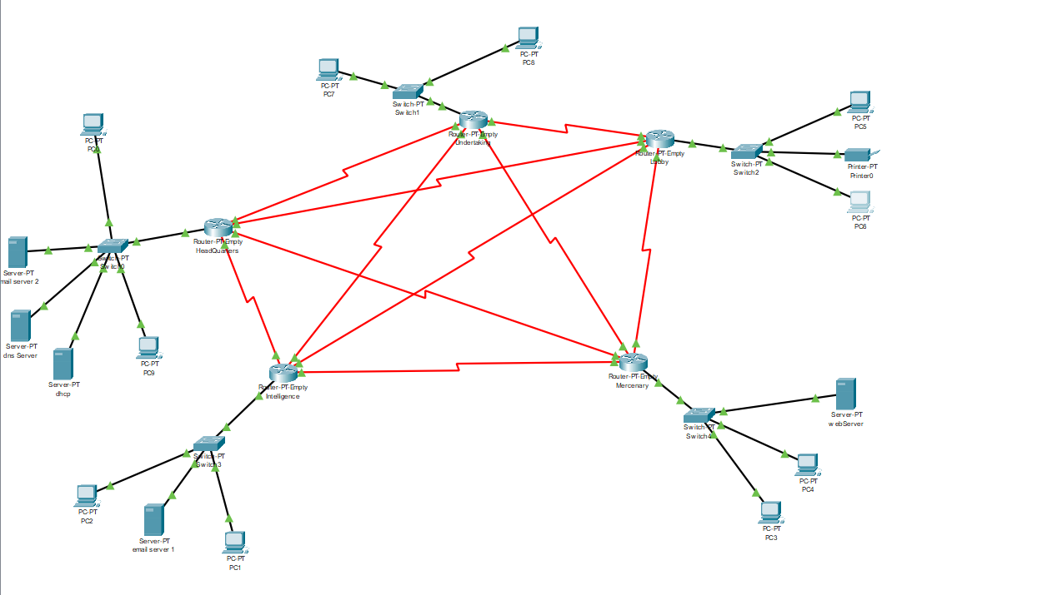

Network diagram

|  |  |  |  |  |  |  |
| --- | --- | --- | --- | --- | --- | --- |
| Name | Hosts Needed | Hosts Available | Network Address | Mask | Usable Range | Broadcast |
| Lobby | 3200 | 4094 | 192.168.0.0 | 255.255.240.0 | 192.168.0.1 - 192.168.15.254 | 192.168.15.255 |
| Head Quarter | 1432 | 2046 | 192.168.16.0 | 255.255.248.0 | 192.168.16.1 - 192.168.23.254 | 192.168.23.255 |
| Intelligence | 520 | 1022 | 192.168.24.0 | 255.255.252.0 | 192.168.24.1 - 192.168.27.254 | 192.168.27.255 |
| mercenary | 20 | 30 | 192.168.28.0 | 255.255.255.224 | 192.168.28.1 - 192.168.28.30 | 192.168.28.31 |
| Undertaking | 20 | 30 | 192.168.28.32 | 255.255.255.224 | 192.168.28.33 - 192.168.28.62 | 192.168.28.63 |
| head -lobby | 2 | 2 | 192.168.28.64 | 255.255.255.252 | 192.168.28.65 - 192.168.28.66 | 192.168.28.67 |
| head - intel | 2 | 2 | 192.168.28.68 | 255.255.255.252 | 192.168.28.69 - 192.168.28.70 | 192.168.28.71 |
| head - merc | 2 | 2 | 192.168.28.72 | 255.255.255.252 | 192.168.28.73 - 192.168.28.74 | 192.168.28.75 |
| head - under | 2 | 2 | 192.168.28.76 | 255.255.255.252 | 192.168.28.77 - 192.168.28.78 | 192.168.28.79 |
| lobby - intel | 2 | 2 | 192.168.28.80 | 255.255.255.252 | 192.168.28.81 - 192.168.28.82 | 192.168.28.83 |
| lobby - merc | 2 | 2 | 192.168.28.84 | 255.255.255.252 | 192.168.28.85 - 192.168.28.86 | 192.168.28.87 |
| lobby - under | 2 | 2 | 192.168.28.88 | 255.255.255.252 | 192.168.28.89 - 192.168.28.90 | 192.168.28.91 |
| intel - merce | 2 | 2 | 192.168.28.92 | 255.255.255.252 | 192.168.28.93 - 192.168.28.94 | 192.168.28.95 |
| intel - under | 2 | 2 | 192.168.28.96 | 255.255.255.252 | 192.168.28.97 - 192.168.28.98 | 192.168.28.99 |
| merc - under | 2 | 2 | 192.168.28.100 | 255.255.255.252 | 192.168.28.101 - 192.168.28.102 | 192.168.28.103 |

VLSM table

|  |  |  |
| --- | --- | --- |
| ip address table |  |  |
| name | ip | type |
| pc0 | 192.168.16.2 | DHCP |
| pc1 | 192.168.24.2 | DHCP |
| pc2 | 192.168.24.3 | DHCP |
| pc3 | 192.168.28.2 | DHCP |
| pc4 | 192.168.28.3 | DHCP |
| pc5 | 192.168.0.3 | DHCP |
| pc6 | 192.168.0.4 | DHCP |
| pc7 | 192.168.28.34 | DHCP |
| pc8 | 192.168.28.35 | DHCP |
| pc9 | 192.168.16.3 | DHCP |
| email server 1 | 192.168.16.13 | static |
| email server 2 | 192.168.24.13 | static |
| web server | 192.168.28.28 | static |
| dns server | 192.168.17.0 | static |
| dhcp server | 192.168.16.16 | static |
| printer | 192.168.0.2 | DHCP |